Files folders for the fair data of the published article

Maximizing the [c2]daisy chain to lasso ratio through competitive self-templating clipping reactions by Adrian Saura-Sanmartin, Aurelia Pastor, Alberto Martinez-Cuezva and Jose Berna* published in Chemical Communications, 2022, DOI: 10.1039/D1CC05942D - E-mail: ppberna@um.es

Lasso [1]rotaxane 3:
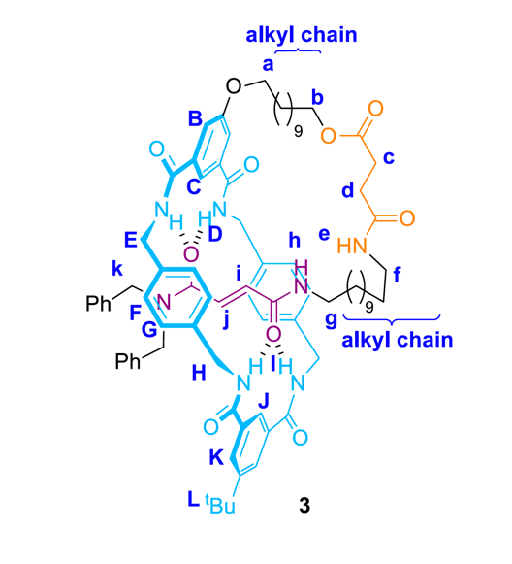 | Fair data for compound 3.zip > ESI-MS >
 | Fair data for compound 3.zip > NMR > 1H >
 | Fair data for compound 3.zip > NMR > 13C >
 | Fair data for compound 3.zip > NMR > COSY >
 | Fair data for compound 3.zip > NMR > HSQC >

[c2]Daisy chain rotaxane 4:

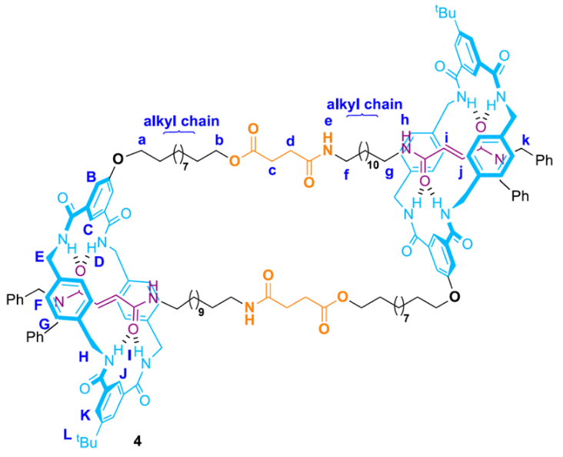 | Fair data for compound 4.zip > ESI-MS >
 | Fair data for compound 4.zip > NMR > 1H >
 | Fair data for compound 4.zip > NMR > 13C >
 | Fair data for compound 4.zip > NMR > COSY >
 | Fair data for compound 4.zip > NMR > HMBC >
 | Fair data for compound 4.zip > NMR > HSQC >
 | Fair data for compound 4.zip > NMR > NOESY >
 | Fair data for compound 4.zip > NMR > ROESY >

