Supplementary Material

Non-indigenous aquatic fauna in transitional waters from the Spanish Mediterranean coast: a comprehensive assessment
José M. Zamora-Marín^{1,2}, Antonio A. Herrero-Reyes¹, Ana Ruiz-Navarro^{1,3}, Francisco J. Oliva-Paterna¹
¹Department of Zoology and Physical Anthropology, Faculty of Biology, University of Murcia, CEIR Campus Mare Nostrum (CMN), Campus de Espinardo, 20100, Murcia, Spain
²Department of Applied Biology, Centro de Investigación e Innovación Agroalimentaria (CIAGRO-UMH), Miguel Hernández University of Elche, Elche, Spain
³Department of Didactics of Experimental Sciences, Faculty of Education, University of Murcia, Campus de Espinardo, 20100, Murcia, Spain
Corresponding author
José Manuel Zamora Marín, Department of Zoology and Physical Anthropology, Faculty of Biology, University of Murcia, Spain. Email: josemanuel.zamora@um.es

Table S1. Name and characteristics of the 30 transitional water sites whose non-indigenous species (NIS) assemblages have been assessed across the Spanish Mediterranean coast. For each site, its corresponding coastal region, name, code and coordinates (degrees, minutes and seconds) are indicated. NIS richness are also provided for each site and include both established, uncertain and cryptogenic inventoried taxa.
Coastal region | Complete site name | Site code | Surface extension | Coordinates  DMS | NIS  richness
Catalan | Parque Natural dels Aiguamolls de l'Empordà y alrededores (Gola del Fluvià y Sant Pere Pescador) | 1 | <50 km² | 42°12'39.8"N 3°06'33.8"E | 84
Catalan | Aiguamolls del Baix Empordà y alrededores (Desembocadura del río Ter, Bassa del Fra Ramon y Les  Basses d'en coll | 2 | <50 km² | 42°01'24.5"N 3°11'24.1"E | 35
Catalan | Delta del Tordera | 3 | <50 km² | 41°39'08.6"N 2°46'36.9"E | 28
Catalan | Parque Fluvial del Besòs | 4 | <50 km² | 41°25'17.2"N 2°13'45.2"E | 27
Catalan | Delta del Llobregat, los Espacios Naturales del Rio Llobregat y alrededores | 5 | <50 km² | 41°17'52.6"N 2°06'38.4"E | 14
Catalan | Parque Natural del Delta del Ebro y alrededores | 6 | >200 km² | 40°42'31.6"N 0°49'41.7"E | 10
Valencian | Parque Natural de Cabanes-Torreblanca | 7 | <50 km² | 40°10'30.4"N 0°11'13.6"E | 44
Valencian | Desembocadura del río Mijares | 8 | <50 km² | 39°54'41.0"N 0°00'52.1"W | 18
Valencian | Paraje Natural Municipal L' Estany y alrededores | 9 | <50 km² | 39°50'08.0"N 0°06'24.0"W | 14
Valencian | Espacio Natural Els Estanys d'Almenara y alrededores | 10 | <50 km² | 39°44'49.0"N 0°11'00.8"W | 13
Valencian | Marjal dels Moros | 11 | <50 km² | 39°37'14.3"N 0°15'29.4"W | 12
Valencian | Parque Natural de l'Albufera de Valencia y Gola del Perellonet | 12 | 50-200 km² | 39°20'00.3"N 0°19'41.9"W | 11
Valencian | Parque Natural del Marjal de Pego-Oliva | 13 | <50 km² | 38°52'23.8"N 0°03'07.3"W | 8
Balearic | Parque Natural de s'Albufera des Grau | 14 | <50 km² | 39°56'54.7"N 4°15'31.0"E | 20
Balearic | Reserva Natural de s'Albufereta | 15 | <50 km² | 39°51'35.6"N 3°05'36.7"E | 5
Balearic | Parque Natural de s'Albufera de Mallorca y s'Estany Gran | 16 | <50 km² | 39°47'55.4"N 3°06'41.2"E | 4
Balearic | Parque Natural de ses salines d'Eivissa i Formentera | 17 | <50 km² | 38°44'07.1"N 1°25'50.2"E | 2
Levantine | Desembocadura del Rio Algar | 18 | <50 km² | 38°36'22.8"N 0°02'31.6"W | 19
Levantine | Parque Natural de las Salinas de Santa Pola | 19 | <50 km² | 38°10'39.4"N 0°37'00.4"W | 10
Levantine | Desembocadura del Segura y Dunas de Guardamar y PN El Hondo | 20 | <50 km² | 38°06'26.1"N 0°39'16.5"W | 9
Levantine | Parque Natural de las Lagunas de La Mata y Torrevieja | 21 | <50 km² | 38°02'05.9"N 0°41'36.7"W | 6
Levantine | Mar Menor; Parque Regional de las Salinas y Arenales de San Pedro del Pinatar y Calbalnque, | 22 | 50-200 km² | 37°42'53.4"N 0°46'20.8"W | 9
Alboran | Parque Natural de Cabo de Gata-Níjar (Zona de Albufera de Cabo de Gata y Rambla Morales) | 23 | <50 km² | 36°45'48.7"N 2°13'17.7"W | 9
Alboran | Paraje Natural Punta Entinas-Sabinar y Lago Victoria | 24 | <50 km² | 36°41'55.0"N 2°41'22.2"W | 7
Alboran | Reserva Natural Albufera de Adra | 25 | <50 km² | 36°45'06.3"N 2°57'01.0"W | 6
Alboran | Paraje Natural Desembocadura Rio Vélez | 26 | <50 km² | 36°43'42.0"N 4°06'27.8"W | 4
Alboran | Parque Natural Desembocadura del Guadalhorce | 27 | <50 km² | 36°40'24.9"N 4°27'25.1"W | 3
Alboran | Desembocadura Río Guadalmansa | 28 | <50 km² | 36°27'10.7"N 5°03'27.6"W | 2
Alboran | Desembocadura y Estuario del Río Guadiaro | 29 | <50 km² | 36°17'08.3"N 5°17'00.2"W | 2
Alboran | Desembocaduras en la Bahía de Algeciras | 30 | <50 km² | 36°10'18.5"N 5°26'36.8"W | 19

Table S2. NODF metrics as resulted from the nestedness analysis (online tool NeD; https://ecosoft.alwaysdata.net/) applied to data on non-indigenous species assemblages in Spanish Mediterranean transitional waters. Z-score and RN (relative nestedness) indices are also provided.
Metric | Index | Z-Score | RN | Nested?
NODF | 45.904 | 23.337 | 1.411 | Yes (p<0.001)
NODF_row | 44.381 | 21.803 | 1.336 | Yes (p<0.001)
NODF_col | 72.59 | 36.472 | 2.678 | Yes (p<0.001)
T | 5.863 | -11.334 | -0.788 | Yes (p<0.001)
BR | 138.0 | -17.447 | -0.559 | Yes (p<0.001)

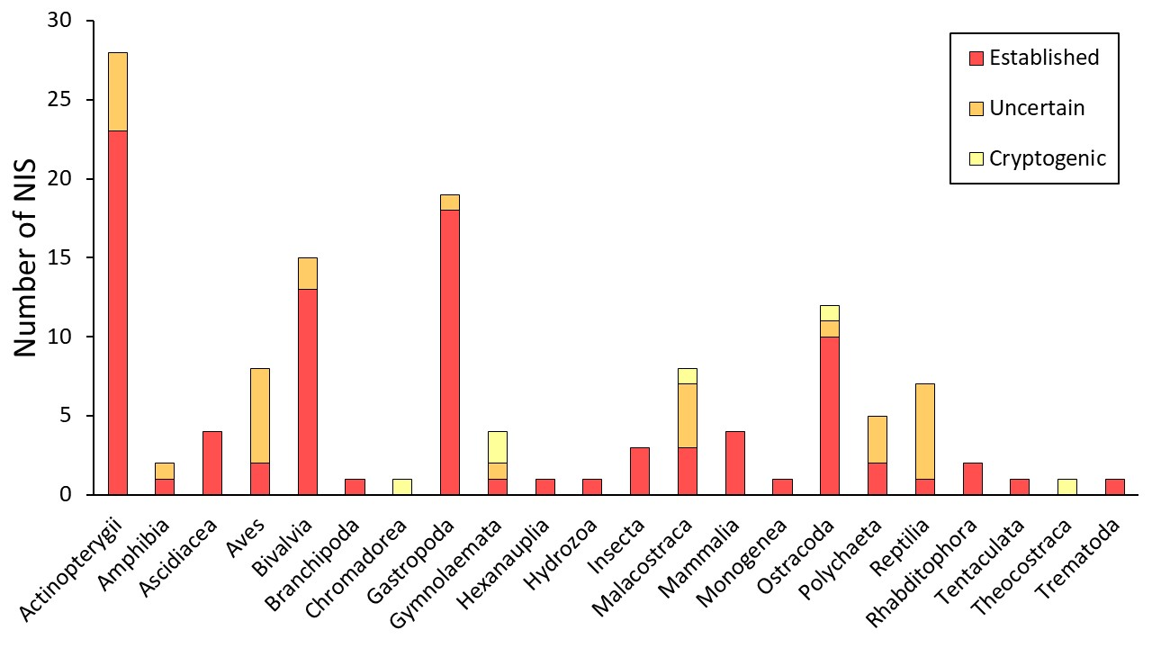
Fig. S1. Richness of non-indigenous animal species (NIS) per taxonomic class recorded in the 30 transitional waters assessed along the Spanish Mediterranean coast. Color indicates the proportion of species which maintain self-sustaining populations (established), do not maintain self-sustaining populations but have been already recorded in the study area and are clearly non-indigenous (uncertain) or their biogeographic origin remains unclear (cryptogenic).

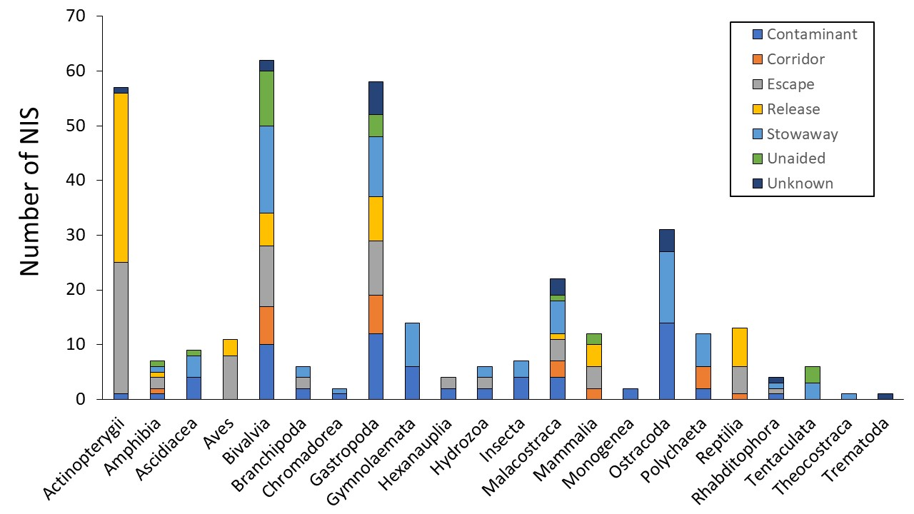
Fig. S2. Taxonomic class-level contribution of different introduction pathways to the arrival of non-indigenous species (NIS) to Spanish Mediterranean transitional waters. Note that most of the recorded NIS (67%) were associated to two or more introduction pathways.

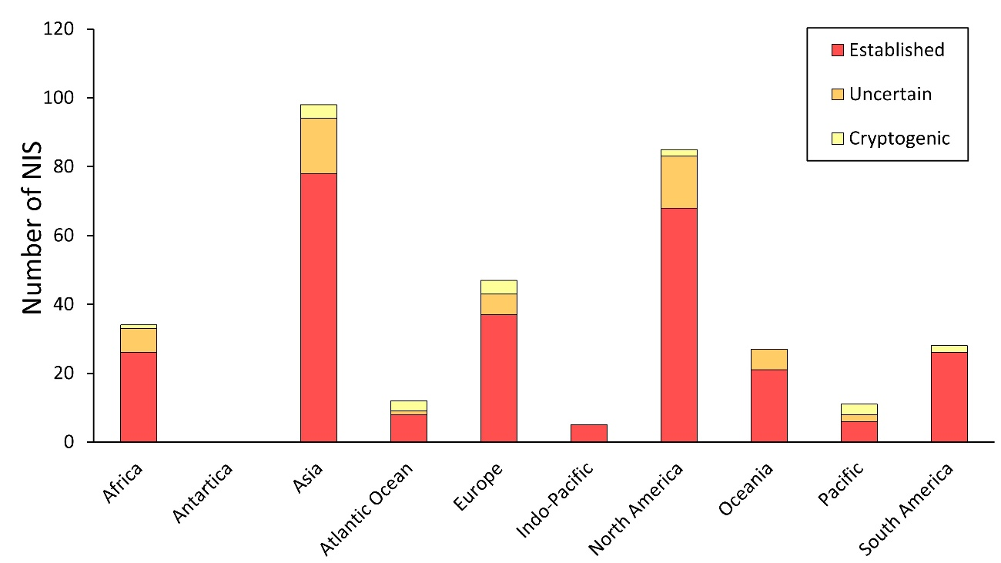
Fig. S3. Biogeographic realms of origin for the non-indigenous animal species (NIS) recorded across transitional waters from the Spanish Mediterranean coast. Note that some NIS may come from two or more realms of origin. Information on native range was extracted from EASIN. Color indicates the proportion of species which maintain self-sustaining populations (established), do not maintain self-sustaining populations but have been already recorded in the study area and are clearly non-indigenous (uncertain) or their biogeographic origin remains unclear (cryptogenic).

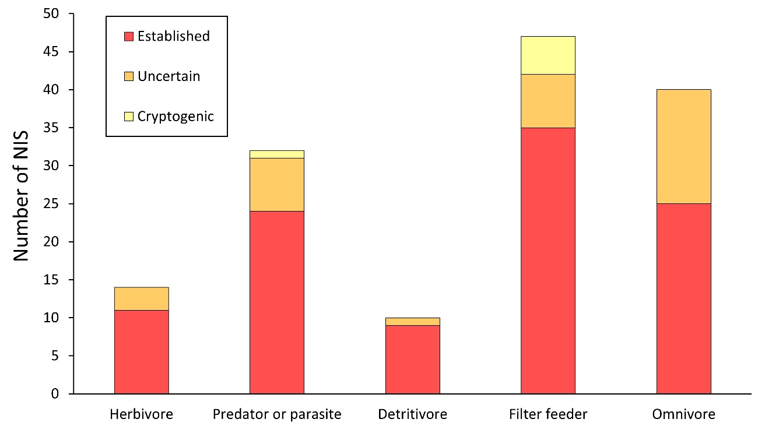
Fig. S4. Richness of non-indigenous species (NIS) per functional group in Spanish Mediterranean transitional waters. Color indicates the proportion of species which maintain self-sustaining populations (established), do not maintain self-sustaining populations but have been already recorded in the study area and are clearly non-indigenous (uncertain) or their biogeographic origin remains unclear (cryptogenic).

